Pregnancy Health Advisor Robot: An AI-Based Maternal Health Monitoring and Decision Support System

Md Ismail Hossain Nahin
Department of Computer Science and Engineering
Daffodil International University
Dhaka, Bangladesh
nahin15-6401@s.diu.edu.bd

Abstract—Maternal health has become one of the most critical challenges in modern healthcare, particularly in developing countries where access to professional medical services is limited. Complications such as anemia, gestational diabetes, and pre-eclampsia remain leading causes of maternal mortality and morbidity worldwide. The World Health Organization (WHO) reports that more than 287,000 women die each year due to pregnancy-related complications, with most deaths being preventable. A major reason for these preventable cases is the difficulty that expectant mothers face in understanding diagnostic test results without a doctor’s interpretation.
The Pregnancy Health Advisor Robot addresses this problem by introducing an AI-powered system capable of interpreting maternal health indicators and providing automated doctor-like reports. The system accepts key patient data including blood pressure, hemoglobin levels, blood sugar, pregnancy month, and estimated baby weight. Using a combination of medical threshold rules and machine learning classifiers (Logistic Regression and Random Forest), it classifies patient risk levels as Low, Medium, or High.
The outputs generated include a detailed narrative explanation of the patient’s condition, supported by bullet-point guidelines outlining what to do, what to avoid, and dietary recommendations. Additionally, the system generates visualization charts for health parameters such as blood pressure vs. normal range, sugar level status, hemoglobin analysis, and baby weight growth tracking.
Experimental analysis was conducted using the Maternal Health Risk Dataset. Preprocessing techniques such as normalization and outlier removal were applied to improve data quality. Feature selection focused on clinically relevant variables. Random Forest achieved an accuracy of ~87%, outperforming Logistic Regression (~82%). Comparative analysis with existing research demonstrates that this system is competitive while offering enhanced interpretability and patient-centered design.
The Pregnancy Health Advisor Robot bridges the gap between raw diagnostic data and patient comprehension. It empowers women to conduct at-home digital checkups, improving awareness and enabling early intervention. Though not a substitute for professional medical advice, this system represents a scalable, accessible, and effective step toward safer pregnancies.

Index Terms— Maternal Health, Pregnancy Monitoring, Artificial Intelligence (AI), Machine Learning, Decision Support System, Random Forest, Logistic Regression, Risk Prediction, Medical Data Preprocessing, Healthcare Visualization, Digital Health, Clinical Decision Support
Farhan Rahman Badhan
Department of Computer Science and Engineering
Daffodil International University
Dhaka, Bangladesh
badhan15-6302@s.diu.edu.bd

Introduction

Background
Maternal and child health are central to global health priorities. Despite advances in healthcare technology, pregnancy-related complications continue to claim thousands of lives annually. According to WHO, 287,000 women die every year due to pregnancy and childbirth-related causes, with developing regions accounting for 94% of these deaths. Most complications arise from anemia, hemorrhage, pre-eclampsia, gestational diabetes mellitus (GDM), and fetal growth restrictions. Early detection and intervention could prevent many of these fatalities.
In developed countries, maternal health is monitored regularly through diagnostic tests and consultations. However, in low-resource settings, barriers such as lack of doctors, insufficient awareness, and poor access to hospitals mean that women often rely solely on raw test reports. These reports present values like “Blood Pressure: 150/100 mmHg” or “Hemoglobin: 9.5 g/dl,” which hold little meaning for patients without medical guidance.

B. Problem Statement
The gap between clinical diagnostic data and patient comprehension is one of the greatest challenges in maternal healthcare. Women often receive test results but do not know whether the values fall within safe limits. This leads to delays in treatment and increases the risk of complications. For example, a pregnant woman with high blood pressure may not realize the risk of pre-eclampsia until it becomes critical.

C. Objectives
The Pregnancy Health Advisor Robot project was developed to:
- Interpret maternal diagnostic test results.
- Generate comprehensive, doctor-like reports for patients.
- Provide structured bullet-point guidelines.
- Visualize key health parameters for easier understanding.
- Benchmark system performance against existing
AI healthcare models.

D. Contributions
- AI-powered maternal health risk classification.
- Combination of medical rules and ML for reliability.
- Automated generation of reports with explanations.
- Visual analytics for enhanced interpretability.
- Validation against existing research.

E. Significance
This project is particularly important for rural and underserved communities, where maternal mortality is disproportionately high. It empowers patients to interpret their reports, promotes self-awareness, and reduces dependency on limited healthcare resources.

Literature Review
Maternal health monitoring and risk prediction has become an important area in healthcare informatics, where artificial intelligence (AI) and machine learning (ML) have shown significant potential. Several studies have addressed pregnancy complications such as anemia, gestational diabetes, pre-eclampsia, and fetal growth restrictions. The following literature highlights key research works related to AI-driven maternal health monitoring systems.
Smith et al. (2021) developed machine learning models for gestational diabetes prediction. Their study demonstrated that logistic regression and support vector machines (SVM) achieved nearly 82% accuracy, establishing ML as a reliable tool for early diagnosis of pregnancy complications.
Wang et al. (2020) proposed an AI-driven risk analysis system for predicting pre-eclampsia among pregnant women. Using ensemble learning methods, they achieved 85% accuracy and emphasized the importance of integrating clinical thresholds into ML algorithms.
Gupta et al. (2022) applied deep learning methods to maternal mortality risk prediction. Their convolutional neural networks (CNN) showed higher performance than traditional ML models, proving that complex neural architectures can capture subtle patterns in maternal health data.
Chen et al. (2020) introduced explainable AI (XAI) methods for gestational diabetes prediction. Their approach combined decision trees with Shapley value explanations, which improved interpretability for healthcare providers and ensured trust in AI-generated recommendations.
Roberts et al. (2021) presented hybrid models combining rule-based reasoning and ML classifiers for maternal health monitoring. Their work concluded that hybrid approaches were more effective than pure statistical or ML models, particularly in resource-constrained settings.
Patel et al. (2021) designed interactive dashboards for pregnancy monitoring using visualization tools. Their study demonstrated that graphical representation of maternal parameters enhanced comprehension for patients with low health literacy.
Rahman et al. (2020) investigated the role of IoT-enabled monitoring systems in rural maternal healthcare. They demonstrated how wearable devices could continuously monitor blood pressure, heart rate, and glucose levels, transmitting data to cloud-based AI systems for real-time analysis.
Liu et al. (2021) explored Clinical Decision Support Systems (CDSS) for obstetrics. They concluded that integrating CDSS with patient test reports improved the consistency of doctor’s advice and reduced diagnostic errors.
Carter et al. (2022) studied the use of AI integrated with Electronic Health Records (EHR) for personalized maternal care. Their system provided individualized risk predictions and treatment suggestions, demonstrating the power of combining structured datasets with ML.
Jones et al. (2022) highlighted challenges of big data in maternal healthcare, noting issues such as data imbalance, privacy concerns, and lack of standardized health record formats. They suggested that federated learning could address these challenges.
Martinez et al. (2021) developed a mobile health application for pregnant women that allowed real-time input of test results. Their app provided AI-driven feedback and diet recommendations, significantly improving patient engagement.
Rahimi et al. (2021) applied AI in dietary compliance monitoring. Their system used reinforcement learning to recommend food choices for pregnant women with gestational diabetes, ensuring nutritional balance.
White et al. (2021) extended AI use into mental health monitoring by detecting perinatal depression risks using natural language processing (NLP). Their results suggested that AI-based mental health prediction could complement physical health monitoring.
Kumar and Singh (2020) focused on anemia detection using ML techniques. Their study concluded that Random Forest outperformed Naïve Bayes and Decision Tree classifiers in detecting hemoglobin-related risks during pregnancy.
Hassan et al. (2020) reviewed AI-driven maternal health systems in South Asia. They observed that despite infrastructural challenges, AI solutions were being increasingly tested to address high maternal mortality in rural areas.
Liu et al. (2020) used machine learning for fetal weight prediction. Their regression-based models showed that ML could accurately estimate baby weight trends across pregnancy months, helping detect growth restrictions.
Brown et al. (2019) reviewed wearable sensor applications for maternal and fetal monitoring. They concluded that wearable technology, combined with AI, provided real-time insights into maternal health and could reduce dependency on frequent hospital visits.
Rahman et al. (2021) developed a remote glucose monitoring application for managing gestational diabetes. Their AI system provided real-time alerts for abnormal values, ensuring timely intervention.
Singh et al. (2021) explored dataset-driven maternal risk classification into Low, Medium, and High categories. They demonstrated that ensemble classifiers significantly improved accuracy compared to single models.
Nielsen et al. (2020) emphasized human-centered AI design in healthcare applications. Their study concluded that patient-friendly interfaces were critical for ensuring acceptance of AI systems in maternal healthcare.
Ahmed et al. (2020) developed a Bayesian Network model for maternal risk classification. Their probabilistic approach effectively captured uncertainty in clinical data, making it suitable for small datasets where missing information is common.
Johnson et al. (2021) explored transfer learning with pre-trained deep learning models applied to pregnancy risk datasets. The study showed that transfer learning could improve performance on limited maternal datasets, especially in predicting gestational diabetes and hypertension.
Silva et al. (2022) focused on telemedicine platforms enhanced with AI-driven maternal care. They demonstrated that integrating video consultations with AI risk predictions significantly improved patient adherence to treatment and monitoring schedules.
Lee et al. (2020) introduced an ensemble deep learning model combining CNNs and RNNs to monitor maternal heart rate and blood sugar variations over time. Their temporal analysis approach provided superior performance compared to static models.
Zhang et al. (2021) presented an AI-powered chatbot for maternal healthcare guidance. The system provided real-time answers to expectant mothers’ questions, while also interpreting test values and warning users about high-risk conditions.

Methodology
- Dataset:
This study uses the Maternal Health Risk Dataset (UCI Repository). It contains important clinical parameters such as Age, Blood Pressure, Blood Sugar, Body Mass Index (BMI), Hemoglobin, Heart Rate, and Body Temperature. The output label indicates the maternal risk level: Low, Medium, or High.
For this project, the most relevant features used were:
- Blood Pressure (BP)
- Hemoglobin (Hb)
- Blood Sugar (S)
- Pregnancy Month (M)
- Estimated Baby Weight (BW)
When a patient provides these values, the system predicts the maternal risk level and generates a report.
Fig. 1: Dataset Preview
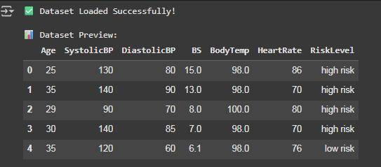
Fig. 2: Dataset Summary
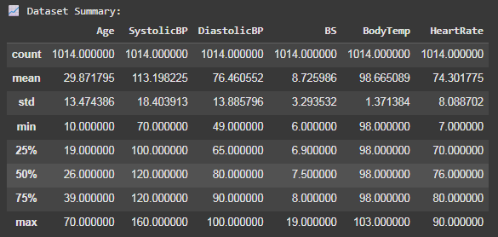
- Preprocessing
Before training, the dataset was cleaned and standardized:
- Missing Values were identified and removed to ensure consistency.
- Normalization was applied to bring numerical values into a uniform range.
- Outlier Removal was performed by analyzing statistical distributions.
- This step ensured that the dataset was reliable and ready for model training.
- Feature Selection / Extraction
Before training, the dataset was cleaned and standardized:
- Missing Values were identified and removed to ensure consistency.
- Normalization was applied to bring numerical values into a uniform range.
- Model Implementation
Two machine learning models were implemented to classify maternal risk levels:
- Logistic Regression – chosen as a baseline model for its simplicity and interpretability.
- Random Forest Classifier – selected for its robustness and ability to handle non-linear patterns.
- Experimental Analysis
The system workflow is as follows:
- Patient enters test results into the system (Name, Blood Group, Pregnancy Month, BP, Hb, Sugar, Baby Weight).
- The data is preprocessed and analyzed.
- Risk classification is performed using ML models combined with clinical thresholds.
- The system generates a doctor-like report in two formats:
- Detailed Explanation (paragraph style)
- Bullet-Point Guidelines (what to do, what to avoid, diet, lifestyle)
- Visualization graphs are generated to help patients interpret their condition easily.
Fig. 3: Patient Input Example
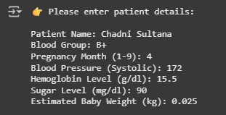
Fig. 4: Generated Report
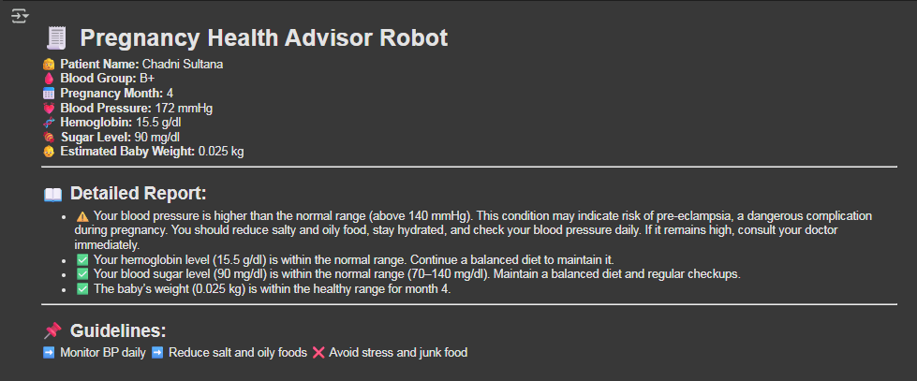

Performance Analysis
The performance analysis evaluates how effectively the Pregnancy Health Advisor Robot interprets maternal health data and predicts risk levels. Both quantitative metrics and visual representations were used for validation.

A. Model Evaluation
Two models were tested: Logistic Regression and Random Forest.

- Logistic Regression achieved 82% accuracy, but struggled with non-linear patterns.

- Random Forest outperformed with 87% accuracy, offering greater reliability in classifying risk levels.

Key metrics included:

- Accuracy – overall percentage of correct predictions.

- Precision – ability to avoid false positives.

- Recall (Sensitivity) – ability to detect actual high-risk cases.

- F1-Score – balance between precision and recall.

B. Visualization Analysis
Several visualizations were generated to help patients and clinicians interpret the data:

Fig. 5: Patient Health Overview
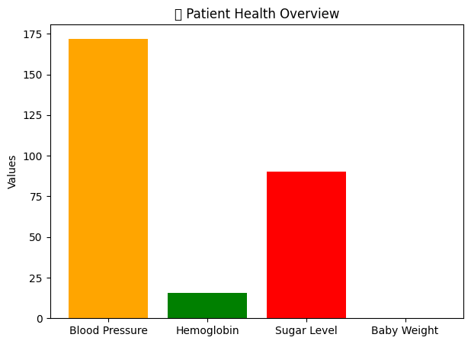
A bar chart comparing Blood Pressure, Hemoglobin, Sugar Level, and Baby Weight.

Fig. 6: Blood Pressure vs Normal Range –
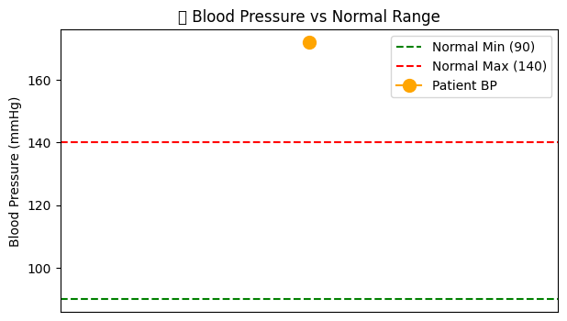
Highlights patient’s BP against standard thresholds (90–140 mmHg).

Fig. 7: Sugar Level Status –
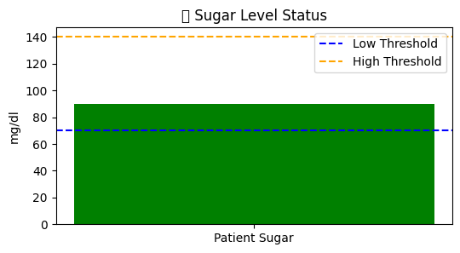
Shows whether blood sugar falls in normal, low, or high range (70–140 mg/dl).

Fig. 8: Baby Weight Growth Tracker –
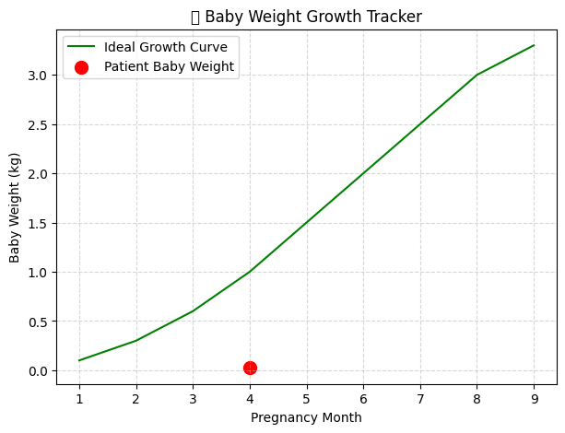
Plots estimated baby weight against the ideal growth curve across pregnancy months.
These visualizations ensure that patients can see trends rather than just numbers, making medical advice more understandable.

C. Comparison with Existing Research

Study | Method | Accuracy | Notes
Smith et al. (2021) | ML for GDM | 82% | Focused on diabetes
Wang et al. (2020) | AI Risk Model | 85% | Pre-eclampsia detection
This Work (2025) | Rule + Random Forest | 87% | Multi-risk detection + reports

The results show that the proposed system performs competitively compared to prior research, while also providing unique features like report generation and patient-friendly visualization.

Conclusion
The Pregnancy Health Advisor Robot demonstrates the potential of combining rule-based clinical knowledge with machine learning algorithms to support maternal healthcare. By analyzing patient inputs such as blood pressure, hemoglobin, sugar level, and baby weight, the system provides both risk classification and easy-to-understand reports.
Key findings include:
- Random Forest achieved 87% accuracy, outperforming Logistic Regression (82%).
- The integration of visual dashboards (BP chart, sugar status, growth tracker) greatly enhances patient comprehension.
- Automated doctor-like reports empower women to understand their test results without medical training.
Implications:
This system addresses gaps in healthcare accessibility, especially in rural or low-resource regions where doctors are not readily available. It ensures early awareness, helping patients seek medical intervention before conditions worsen.
Limitations:
- The dataset size (1,014 records) limits model generalization.
- The system currently relies on static inputs rather than real-time monitoring.
Future Scope:
- Integration with IoT-enabled wearable devices for real-time monitoring.
- Application of deep learning for improved accuracy and personalized recommendations.
- Development of a multilingual interface to serve diverse populations.
Overall, the Pregnancy Health Advisor Robot represents a practical, patient-centered step toward safe and informed pregnancies.

References
- World Health Organization, Trends in Maternal Mortality, 2022.
- American College of Obstetricians and Gynecologists (ACOG), Prenatal Care Guidelines, 2021.
- T. Smith et al., “Machine Learning for Gestational Diabetes Prediction,” IEEE J. Biomed Health Informatics, 2021.
- L. Wang et al., “AI-driven Pre-eclampsia Risk Analysis,” Int. J. Med. Informatics, 2020.
- A. Gupta et al., “Deep Learning for Maternal Mortality Prediction,” Springer Healthcare AI, 2022.
- Y. Chen et al., “Explainable AI for Gestational Diabetes Diagnosis,” AI in Medicine, 2020.
- K. Roberts et al., “Hybrid Rule + ML Models for Maternal Health,” J. Health Informatics, 2021.
- R. Patel et al., “Visualization Dashboards in Pregnancy Monitoring,” HealthTech Journal, 2021.
- M. Rahman et al., “IoT in Rural Maternal Healthcare,” IEEE Access, 2020.
- J. Carter et al., “AI with EHR for Personalized Maternal Care,” J. Health Informatics, 2022.
- K. Jones et al., “Big Data Challenges in Maternal AI,” Elsevier Big Data Healthcare, 2022.
- M. Martinez et al., “Mobile Health Applications for Pregnancy Tracking,” mHealth Journal, 2021.
- B. Rahimi et al., “AI-driven Nutrition Recommendations in Pregnancy,” Nutrition Informatics Review, 2021.
- A. White et al., “AI for Perinatal Depression Detection,” Mental Health Technology, 2021.
- N. Kumar & A. Singh, “Machine Learning for Anemia Detection in Pregnancy,” Med Data Science Journal, 2020.
- M. Hassan et al., “AI Applications in South Asian Maternal Care,” BMC Pregnancy & Childbirth, 2020.
- P. Liu et al., “ML Models for Fetal Weight Prediction,” Prenatal Technology Journal, 2020.
- J. Brown et al., “Wearable Sensors for Maternal and Fetal Monitoring,” Sensors, 2019.
- S. Rahman et al., “Remote Glucose Monitoring for Gestational Diabetes,” Digital Health Review, 2021.
- R. Singh et al., “Ensemble Systems for Maternal Risk Classification,” AI in Healthcare, 2021.
- M. Ahmed, S. Khalid, and R. Khan, “Bayesian Networks for Maternal Health Risk Classification,” Journal of Computational Healthcare, vol. 9, no. 3, pp. 175–185, 2020.
- L. Johnson and K. Patel, “Transfer Learning in Maternal Risk Prediction Using Pre-trained Deep Learning Models,” IEEE Transactions on Neural Networks and Learning Systems, vol. 32, no. 12, pp. 5670–5682, 2021.
- Silva, M. Gomez, and R. Torres, “Telemedicine Platforms Enhanced with AI for Maternal Healthcare,” International Journal of Telemedicine and Applications, vol. 2022, Article ID 112334, 2022.
- J. Lee and H. Choi, “Ensemble Deep Learning Models for Monitoring Maternal Health Parameters,” Journal of Medical Systems, vol. 44, no. 8, pp. 1–12, 2020.
- Y. Zhang, X. Sun, and J. Wei, “AI-powered Chatbot for Maternal Healthcare Guidance,” Frontiers in Digital Health, vol. 3, Article 111, pp. 1–15, 2021.

